[](http://www.google.co.uk/url?sa=i&rct=j&q=CARTOON+CLIPART&source=images&cd=&cad=rja&docid=86-LAeKeuBgjKM&tbnid=oh6Nzz6KzMbcnM:&ved=0CAUQjRw&url=http://www.crooopy.com/view.php?images=view-full-size-more-arthur-s-animal-cartoon-clipart-page-2&ei=sIQmUcK8JcrZtAaP_oDgCw&bvm=bv.42661473,d.Yms&psig=AFQjCNGA_eXAvZzOxuikvzbyV9ubEACXCw&ust=1361565224084825)

1. Χρωμάτισε το ½ των σχημάτων.

[](http://www.google.co.uk/url?sa=i&rct=j&q=CARTOON+CLIPART&source=images&cd=&cad=rja&docid=41_L2cJaratGdM&tbnid=DzeGXJ3JhEOR4M:&ved=0CAUQjRw&url=http://primoclipart.com/view-clipart/cartoon-penguin-clip-art&ei=5YQmUa2QHsTZtAaG74C4Dw&bvm=bv.42661473,d.Yms&psig=AFQjCNGA_eXAvZzOxuikvzbyV9ubEACXCw&ust=1361565224084825)

1. Βάλε σε κύκλο το ½ των αντικειμένων της κάθε ομάδας.

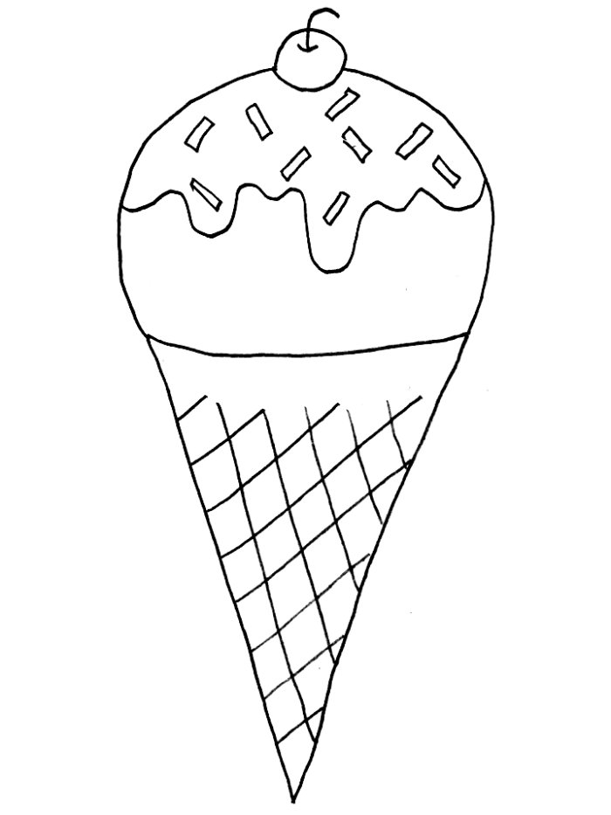το ½ του 8 = ­­_____ το ½ του 10 =  _____







[](http://www.google.com.cy/url?sa=i&rct=j&q=penguin+cartoon&source=images&cd=&cad=rja&docid=yTh8pCzqmccBsM&tbnid=QyAXoQ5tf9UkOM:&ved=0CAUQjRw&url=http://www.istockphoto.com/stock-illustration-4367597-penguin-cartoon.php&ei=igknUeerCMnDswbs24GIBw&bvm=bv.42768644,d.Yms&psig=AFQjCNFnFUI3ioF5iLUdDAEsag0sKAXOLA&ust=1361599235080000)[](http://www.google.com.cy/url?sa=i&rct=j&q=penguin+cartoon&source=images&cd=&cad=rja&docid=19GyBm88UnFZmM&tbnid=1PIP8U7GGOmMLM:&ved=0CAUQjRw&url=http://www.istockphoto.com/stock-illustration-822290-penguin-cartoon.php&ei=JAonUZmqKcfPtAaxsICIDQ&bvm=bv.42768644,d.Yms&psig=AFQjCNFnFUI3ioF5iLUdDAEsag0sKAXOLA&ust=1361599235080000)[](http://www.google.com.cy/url?sa=i&rct=j&q=penguin+cartoon&source=images&cd=&cad=rja&docid=xqa-HlEdMUwZ6M&tbnid=UhiobYhv7kidUM:&ved=0CAUQjRw&url=http://www.istockphoto.com/stock-illustration-11750217-cartoon-penguin.php&ei=AgonUcjrKILcswa0-YHgDQ&bvm=bv.42768644,d.Yms&psig=AFQjCNFnFUI3ioF5iLUdDAEsag0sKAXOLA&ust=1361599235080000)το ½ του 12 = _____ το ½ του 14 = _____

Όνομα:………………………………………………………………………………………………… Τάξη:……………