[](http://www.bing.com/images/search?q=Free+Clipartbath+cartoon+children&view=detail&id=458DC19388531C99E7465AB785A8129CB1C727A1&FORM=IDFRIR)[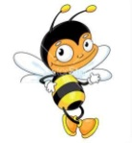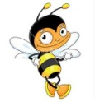](http://www.bing.com/images/search?q=free+clipartcartoon&view=detail&id=75431B3EED9894D37D341B6C161787DBCC3043E7&first=31&FORM=IDFRIR)[](http://www.bing.com/images/search?q=free+clipartcartoon&view=detail&id=706AC982C95B6F391B7409B23F8B7417B5AF011F&FORM=IDFRIR)[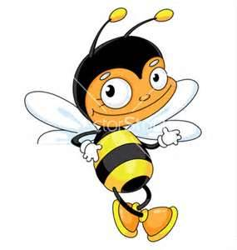](http://www.bing.com/images/search?q=free+clipartcartoon&view=detail&id=75431B3EED9894D37D341B6C161787DBCC3043E7&first=31&FORM=IDFRIR)

[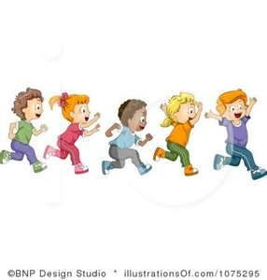](http://www.bing.com/images/search?q=Free+Clipart+run&view=detail&simid=4732071271792794&sid=F051A5A0CEDD42346374FD4EB6033857572A1D37&id=3B231AC345D1A74A8CB420BA2C0BFDC1F0FC982C&FORM=IDFRSI)[](http://www.bing.com/images/search?q=Free+Clipartbath+cartoon+children&view=detail&id=458DC19388531C99E7463722FD066146A5B05E55&FORM=IDFRIR)[](http://www.bing.com/images/search?q=Free+Clipart+eating+&view=detail&id=A11262EFCFFED89F6D3A8EC10852724B18D950FF&FORM=IDFRIR)[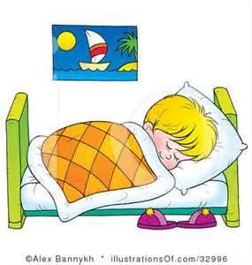](http://www.bing.com/images/search?q=free+clipart+sleeping+child&view=detail&id=0627E177439D3DC856821BF572AD3E14F1680ABE&FORM=IDFRIR)[](http://www.bing.com/images/search?q=Free+Clipart+rose&view=detail&id=C1A827CB28EF12C07F6E1DFF4F40B1E12B95DCED&FORM=IDFRIR)[](http://www.bing.com/images/search?q=Free+Clipartmobile+&view=detail&id=0BAFA8454ECD4CB88695B379BFEE25D33249ABE9&FORM=IDFRIR)[](http://www.bing.com/images/search?q=Free+Clipart+ANIMAL&view=detail&id=64FE04D5E80447A655952EE698219A2ABD794F98&FORM=IDFRIR)[](http://www.bing.com/images/search?q=Free+Clipart+police&view=detail&id=4F377F1A33DC97A924539B01B6A3778657A88E15&first=61&FORM=IDFRIR)

κοιμάται τρώω λούζομαι τρέχουμε

Γράψε 6 δικά σου ΟΥΣΙΑΣΤΙΚΑ:………………………………………………………

…………………………………………………………………………………………………………………

ΟΥΣΙΑΣΤΙΚΑ: Είναι οι λέξεις που μας φανερώνουν:

ΠΡΟΣΩΠΑ ΖΩΑ ΠΡΑΓΜΑΤΑ ΦΥΤΑ

ΡΗΜΑΤΑ: Είναι οι λέξεις που μας φανερώνουν ότι κάποιος

κάνει ή παθαίνει κάτι:

Γράψε 6 δικά σου ΡΗΜΑΤΑ:………………………………………………………………

…………………………………………………………………………………………………………………

[](http://www.bing.com/images/search?q=Free+Clipartbath+cartoon+children&view=detail&id=458DC19388531C99E7465AB785A8129CB1C727A1&FORM=IDFRIR)[](http://www.bing.com/images/search?q=free+clipartcartoon&view=detail&id=75431B3EED9894D37D341B6C161787DBCC3043E7&first=31&FORM=IDFRIR)[](http://www.bing.com/images/search?q=free+clipartcartoon&view=detail&id=706AC982C95B6F391B7409B23F8B7417B5AF011F&FORM=IDFRIR)[](http://www.bing.com/images/search?q=free+clipartcartoon&view=detail&id=75431B3EED9894D37D341B6C161787DBCC3043E7&first=31&FORM=IDFRIR)

[](http://www.bing.com/images/search?q=Free+Clipart+run&view=detail&simid=4732071271792794&sid=F051A5A0CEDD42346374FD4EB6033857572A1D37&id=3B231AC345D1A74A8CB420BA2C0BFDC1F0FC982C&FORM=IDFRSI)[](http://www.bing.com/images/search?q=Free+Clipartbath+cartoon+children&view=detail&id=458DC19388531C99E7463722FD066146A5B05E55&FORM=IDFRIR)[](http://www.bing.com/images/search?q=Free+Clipart+eating+&view=detail&id=A11262EFCFFED89F6D3A8EC10852724B18D950FF&FORM=IDFRIR)[](http://www.bing.com/images/search?q=free+clipart+sleeping+child&view=detail&id=0627E177439D3DC856821BF572AD3E14F1680ABE&FORM=IDFRIR)[](http://www.bing.com/images/search?q=Free+Clipart+rose&view=detail&id=C1A827CB28EF12C07F6E1DFF4F40B1E12B95DCED&FORM=IDFRIR)[](http://www.bing.com/images/search?q=Free+Clipartmobile+&view=detail&id=0BAFA8454ECD4CB88695B379BFEE25D33249ABE9&FORM=IDFRIR)[](http://www.bing.com/images/search?q=Free+Clipart+ANIMAL&view=detail&id=64FE04D5E80447A655952EE698219A2ABD794F98&FORM=IDFRIR)[](http://www.bing.com/images/search?q=Free+Clipart+police&view=detail&id=4F377F1A33DC97A924539B01B6A3778657A88E15&first=61&FORM=IDFRIR)

κοιμάται τρώω λούζομαι τρέχουμε

Γράψε 6 δικά σου ΟΥΣΙΑΣΤΙΚΑ:………………………………………………………

…………………………………………………………………………………………………………………

ΟΥΣΙΑΣΤΙΚΑ: Είναι οι λέξεις που μας φανερώνουν:

ΠΡΟΣΩΠΑ ΖΩΑ ΠΡΑΓΜΑΤΑ ΦΥΤΑ

ΡΗΜΑΤΑ: Είναι οι λέξεις που μας φανερώνουν ότι κάποιος

κάνει ή παθαίνει κάτι:

Γράψε 6 δικά σου ΡΗΜΑΤΑ:………………………………………………………………

…………………………………………………………………………………………………………………